**IT 327 - Lab #6**

**Wire Media Characterization**

# Objective

To analyze Sound Noise Ratio, frequency response, and attenuation of different kinds of cables.

# Procedures

Analyze 4 different cables such as RG59U, TWISTER PAIR, RG6U, and CAT5E. It is possible to use other cables as well just keep track of what type and the results of it.

## Step 1:

Attenuation: to start off you can use the HP 3312A (Analog Signal Generator).

a) Set amplitude to 1.4 KHz signal, by pushing KHz button and adjusting it.

b) Measure voltage on an oscilloscope and print the waveform.

c) Set frequency to 14 MHz by pushing MHz button and adjusting it with same amplitude and measure the voltage again.

e) Repeat steps a-e for all 4 cables. Below you will find the results of all 4 cables.

d) Compute the attenuation using the two voltages measured.

Attenuation = V1P-P - V2P-P

|  |  |  |  |  |  |  |  |
| --- | --- | --- | --- | --- | --- | --- | --- |
| measurement | Cable | 1.4 KHz | | 14 MHz | | Attenuation | |
| 55 ft | RG59U | V1=22 Vp-p | V2=22 Vp-p | V1=4.16 Vp-p | V2=5.848 Vp-p | 0 | -1.688 |
| 1000 ft | TWISTER PAIR | V1=22.4 Vp-p | V2=22.4 Vp-p | V1=4.254 Vp-p | V2=1.146 Vp-p | 0 | 3.108 |
| 6 ft | RG6U | V1=22.4 Vp-p | V2=22.4 Vp-p | V1=3.88 Vp-p | V2=10.09 Vp-p | 0 | -6.21 |
| 16 ft | CAT5E | V1=22.8 Vp-p | V2=22 Vp-p | V1=5.84 Vp-p | V2=4.497 Vp-p | 0.4 | 4.097 |

### Screenshots of all the cables measured in 1.4 KHz and 14 MHz:

RG59U at 1.4 KHz

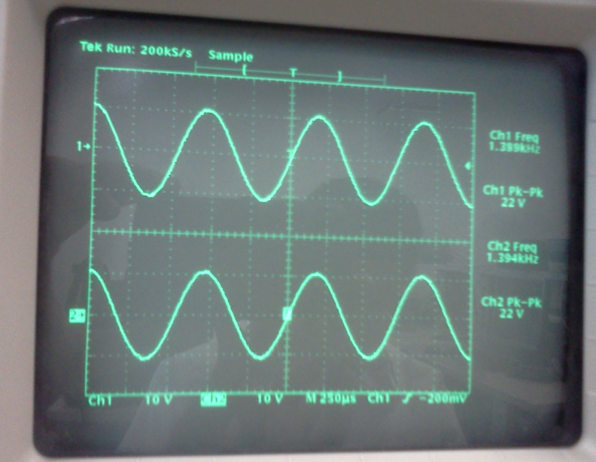

RG59U at 14 MHz

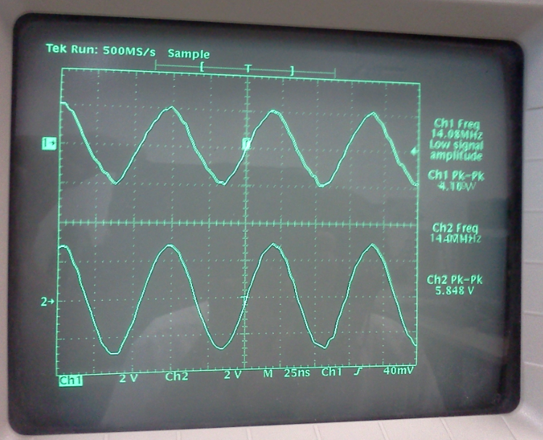

TWISTED PAIR at 1.4 KHz:

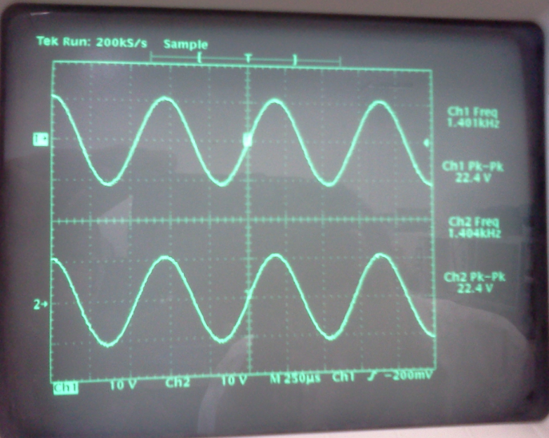

TWISTED PAIR at 14 MHz:

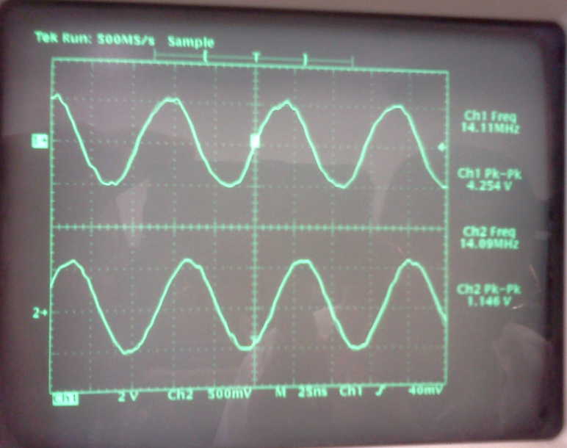

RG6U at 1.4 KHz

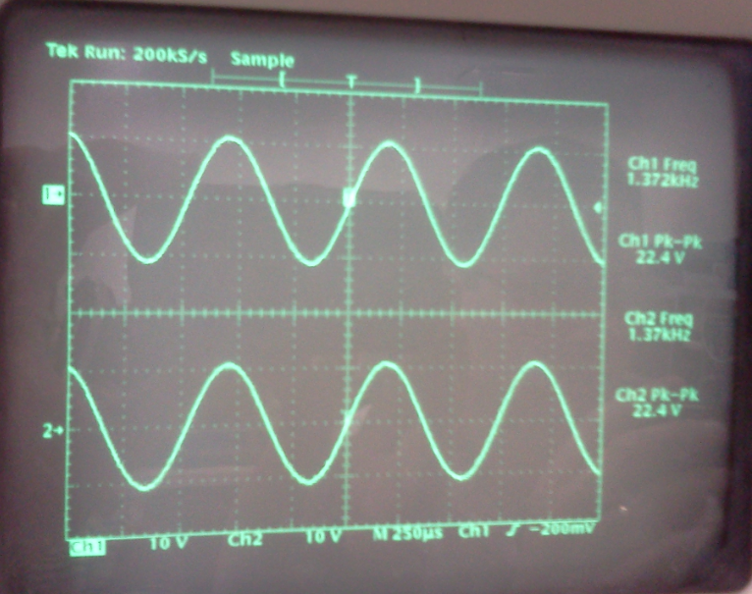

RG6U at 14 MHz

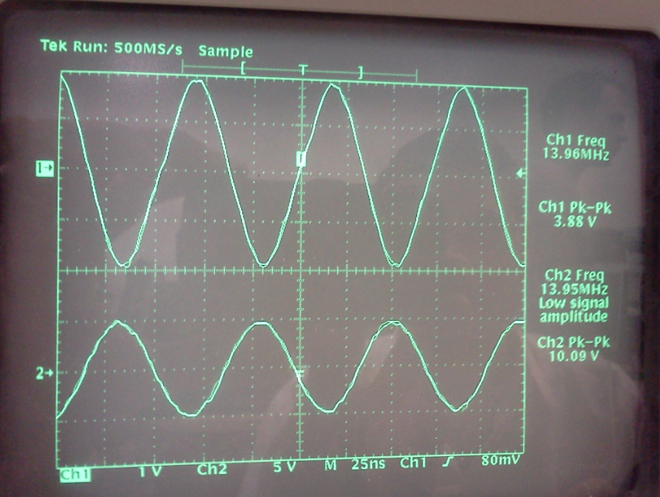

CAT5E at 1.4 KHz

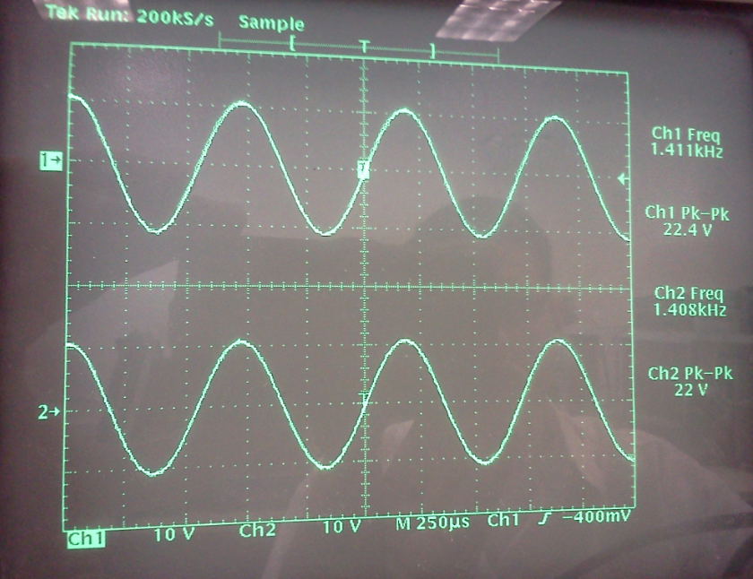

CAT5E at 14 MHz

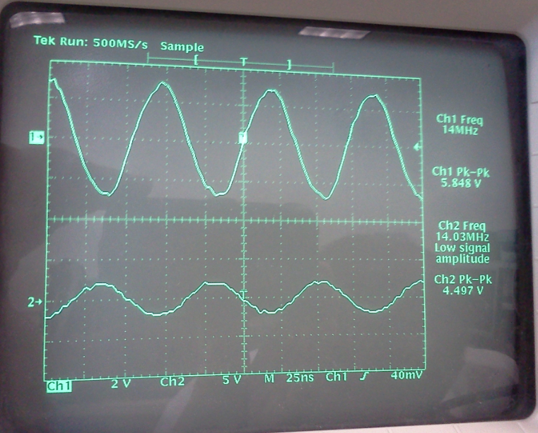

## Step 2

Use the RG59U cable, TIMS with the Adder module, Noise Generator and Wideband True RMS Meter modules to combine noise to the 1.4 MHz signal. Follow the steps below:

a) Connect signal to the one input of the adder (A) using the Scope Selector.

b) Connect the noise on the other input of the adder (B). Then connect the output on the Adder (GA+gB) to IN on the RMS Meter.

c) On RMS Meter, set the left toggle to AC + DC and the right toggle to 10V.

d) Set the level of the noise to 100mVRMS on the RMS Meter module. Make sure to turn the signal knob (G) on the Adder all the way down, or simply unplug the signal, which allows you to measure only the noise.

e) Eliminate the noise (turn down G or unplug B), turn the signal knob (g) all the way up and measure

Signal RMS value.

f) Plug the noise back in and look at the output on an oscilloscope as noise is increased and decreased.

As you follow the above instructions you should get a similar picture of TIMS as found below:

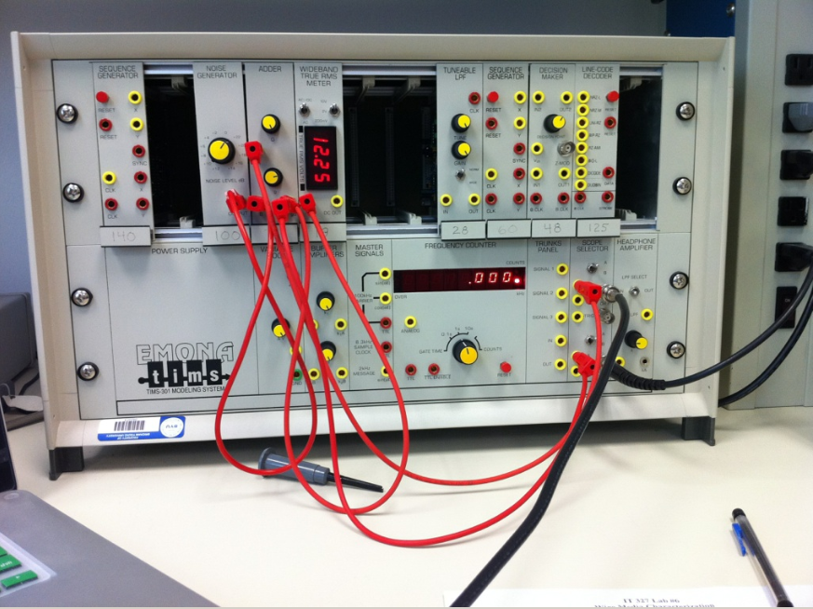

SNR = 20 log10 (Signal rms/ Noise rms)

Signal to Noise Ratio table Caluclation.

|  |  |
| --- | --- |
| Less noise | More noise |
| Signal RMS = 8.18 Vrms | Signal RMS = 7.68 Vrms |
| Noise RMS = 0.10 Vrms | Noise RMS = 1.04 Vrms |
| SNR = 38.26 dB | SNR =17.367 dB |
| Combination = 8.16 Vrms | Combination = 7.72 Vrms |

Screenshot of less noise is found below:

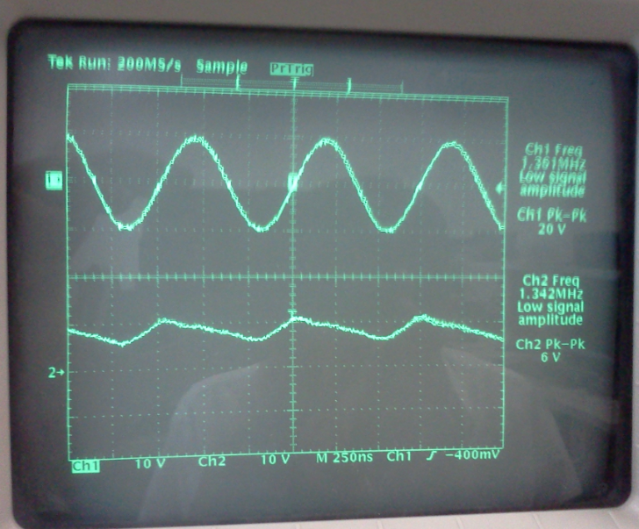

Screenshot or more noise is found below:

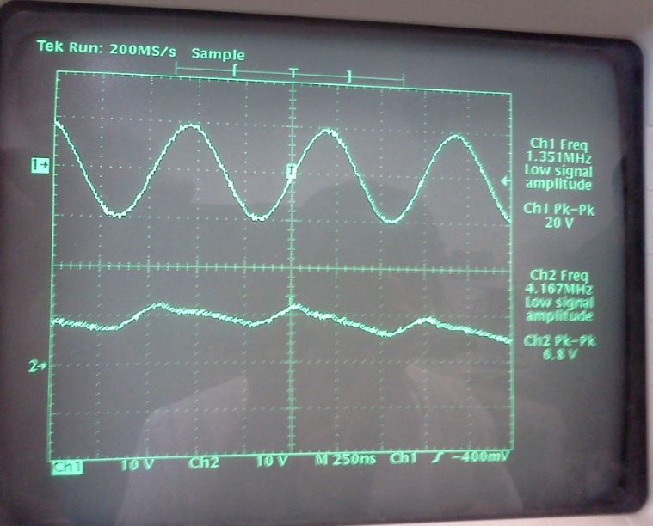

## Step 3

By using the HP 8752A, a network analyzer, analyze the frequency response of all 4 cables.

The channel 1 tells the attenuation of the cable across the frequency spectrum; while channel 2 tells how much power is being reflected back via the cable. Follow the below steps:

a) Connect each cable into RF Out port and RF IN port; make sure to use the appropriate

connectors to do so. The RF Out port will send a signal through the cable to the RF IN port to allow you to take quantities.

b) Set Span to 3 GHz by pressing the span start button and input 0.3 GHz and then press button span end button to 3 GHz.

c) Use a marker search function to determine at what frequency the cable reflects the most amount of

Power, look for min or max point - farther from 0 db.

d) Below you will find pictures of Channel 1 (Attenuation) and Channel 2 (Frequency) and its maximum reflections.

|  |  |  |  |  |
| --- | --- | --- | --- | --- |
|  | Channel 1 | | Channel 2 | |
| Cable | Frequency | Max Attenuation (dB) | Reflection | Max Attenuation (dB) |
| RG59U | 1.425757444 (GHz) | -20.757 | 514.14863 (MHz) | -20.468 |
| TWISTED PAIR | 2.520048044 (GHz) | -27.546 | 1.438956126 (GHz) | -20.797 |
| RG6U | 2.505049482 (GHz) | -16.555 | 2.93970602 (GHz) | -4.3287 |
| CAT5E | 584.341616 (MHz) | -33.257 | 515.348516 (MHz) | -12.002 |

RG59U Screenshot Channel 1:

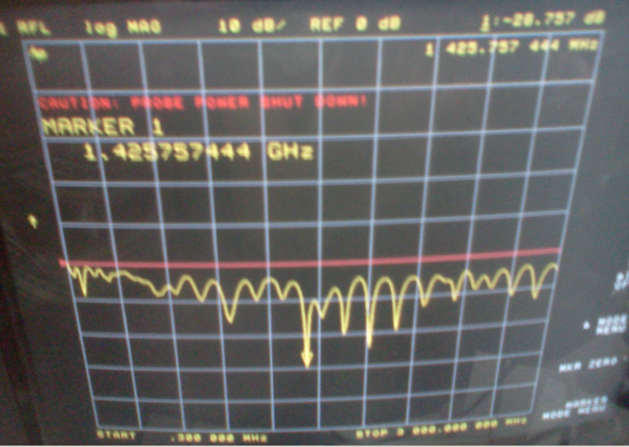

RG59U Screenshot Channel 2:

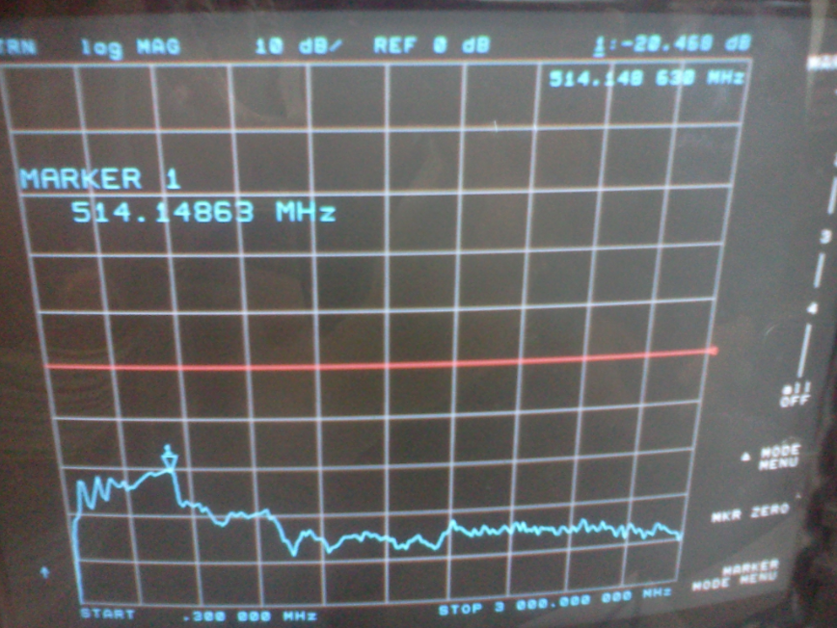

TWISTED PAIR screenshot Chanel 1:

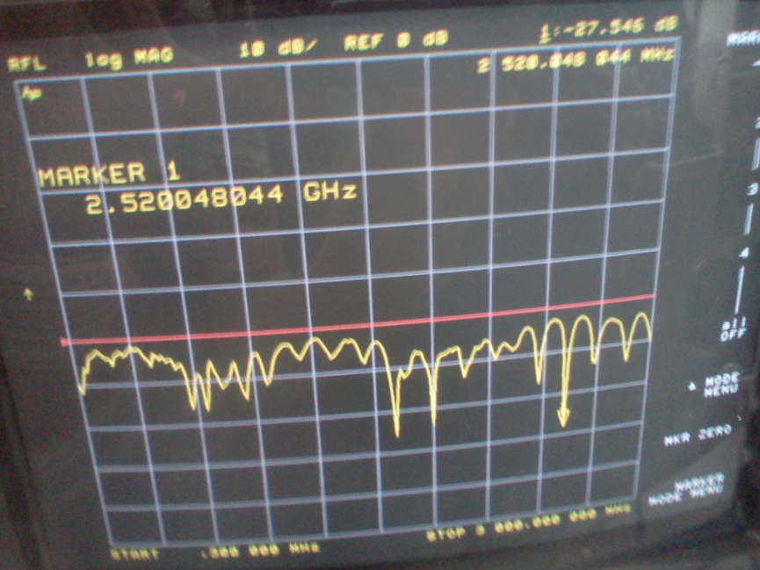

TWISTED PAIR screenshot Chanel 2:

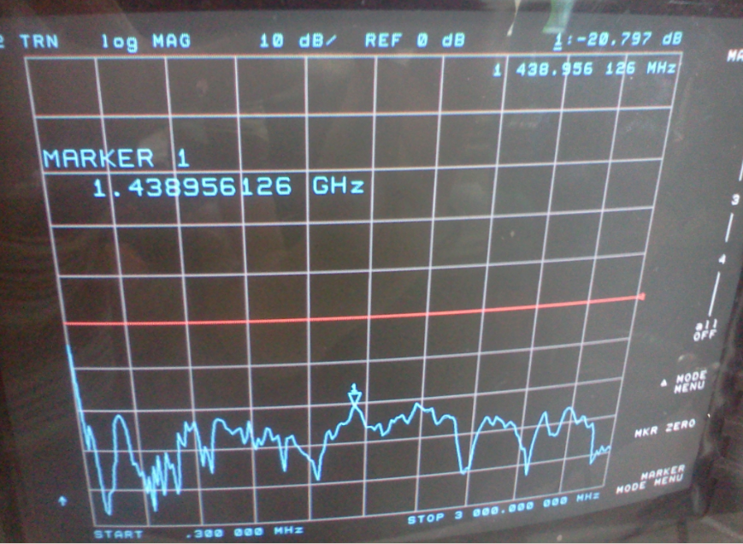

RG6U Screenshot of channel 1:

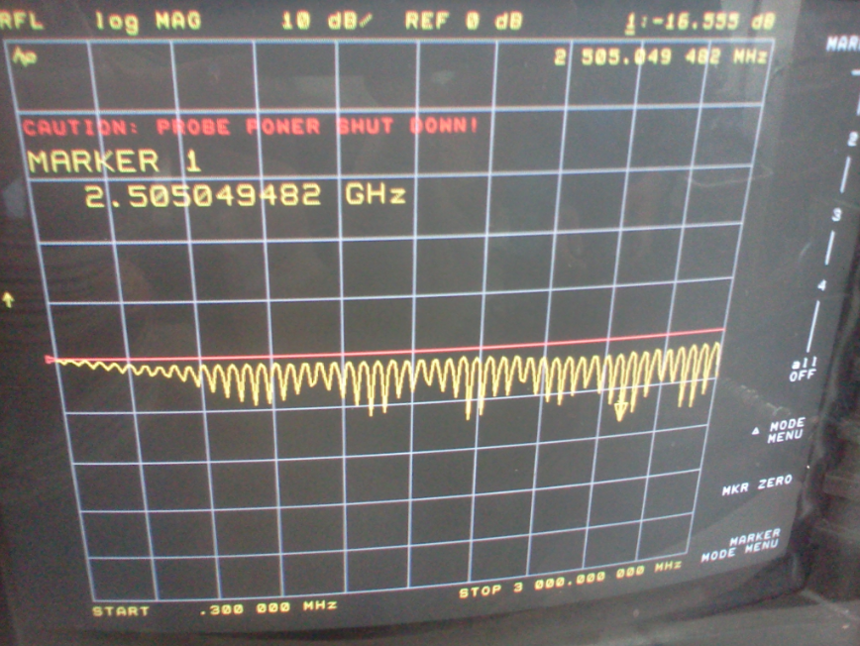

RG6U Screenshot of channel 2:

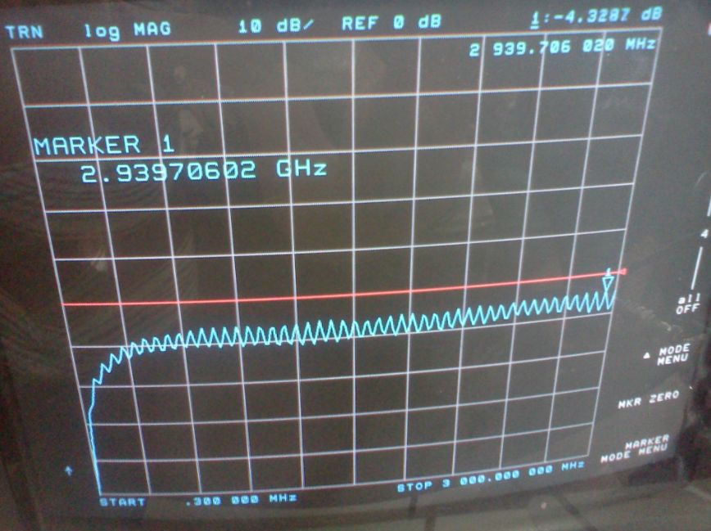

CAT5E Screenshot channel 1:

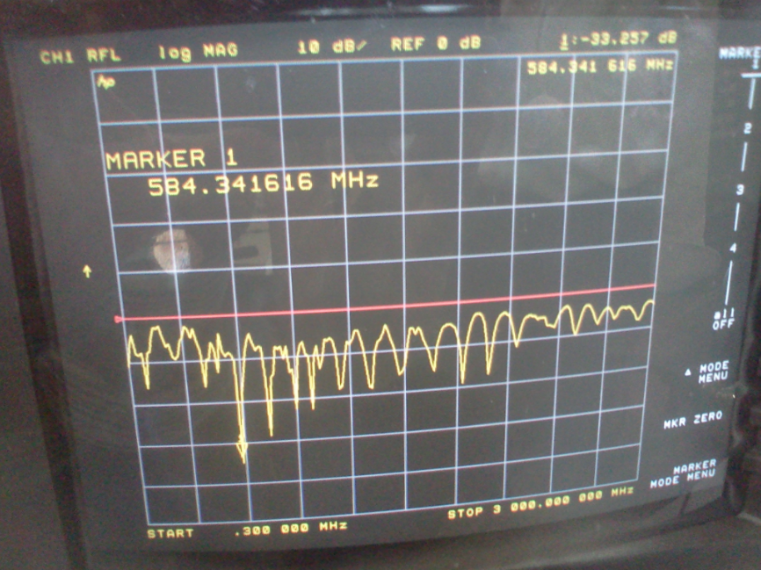

CAT5E Screenshot channel 2:

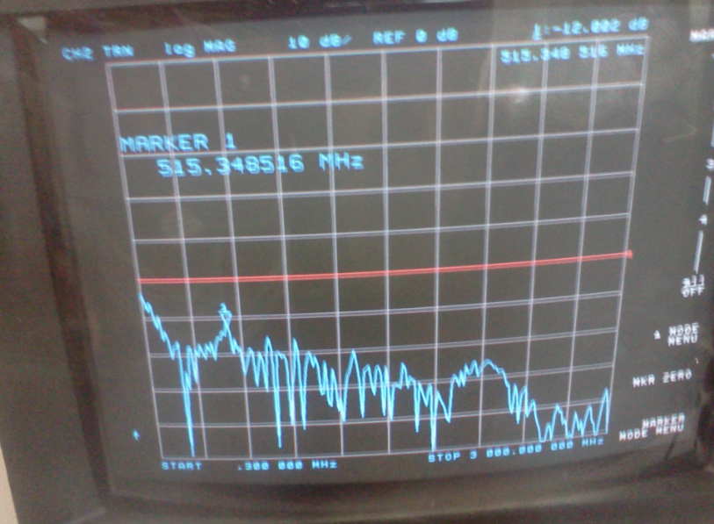

# Equipment Used

* Emona Tims equipment- Manufacture: Emona Instruments.
* Analog signal generator, model: HP 3312A
* Oscilloscope: Tektronix TDS 320 model.
* Network Analyzer, model HP 8752A

# Report

Attenuation is the gradual loss in intensity of the propagation of waves and signals and electric circuits. Measuring the attenuation that each cable is an important step in figuring out the best cable to accomplish a task. The less attenuation from a cable the better.

The lab was educational and it was important to me to see the relationships of the measured attenuation and its corresponding cables, and compare each cable and see how efficient each cable is. Also to see the expected calculations using Attenuation = V1p-p – V2p-p

Seeing the resulting attenuation of each cable and its reflection back through each cable was an important lesson because it taught me where the point of reflection is visually and same with time the attenuation of the cable.

It is also important as we measure the frequency response and attenuation of each cable set enough span as to see the behavior of each frequency related to a cable. I had a few difficulties in setting up the correct span for this assignment mostly due to a new machine to learn, but with a few trial and error I was able to set the right setting to get this lab specification done.

# Conclusion

This lab has reinforced me the importance of attenuation and its correlation with each cable. It was also important to see the relation of formulas and device readers, they co-relate very well, as expected.

It is important to know the Signal Noise Ratio of each cable as to know the strengths and weaknesses of each cable. Signal Noise Ration compares the level of a desired signal to the level of background noise.

The frequency response is a quantitative measure of the output spectrum of a system or device in response to a stimulus; its use is to characterize the dynamics of the system. It is a measure of magnitude and phase of the output as a function of frequency, in comparison to the input. They all had different frequency response.

Certain cables are better off than others in terms of speed and less attenuation, and this lab has taught me to be more specific when dealing with a project as to analyze which cable is best for a given project.

**Name: Lehi Alcantara**

**Completion Date: 10/11/2011**